7 March 2026
NAME: BADIA SHAMSI | Age: AD | Sex: F
Clinical Details: OBS
OBSTETRICS ULTRASOUND REPORT
Maternal Survey:
Internal Os is closed.
Adnexa appear unremarkable.
Foetal Survey: -
- Sonogram revealed SINGLE intrauterine foetus.
- Presentation : BREECH, Lying LONGITUDINAL
- Placenta Location : ANTERIOR
- Amniotic fluid : ADEQUATE
- Cardiac activity : PRESENT AND REGULAR

\Biometry:
- Gestation age based on BPD, HC and FL is approximately (GA): 31 weeks 04 day(s)
- Expected date of delivery by USG DD) : 09/05/2026 (±2 weeks)
- Foetal weight : 1.74 kg
- SEX: : XY(MALE)
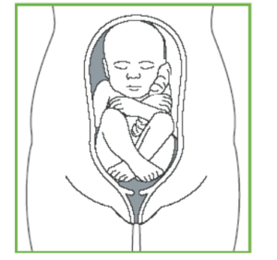
IMPRESSION: Single live intrauterine foetus at 31 weeks 04 day(s).
Sonographer

